**BUILD AN EMPLOYEE TRAVEL APPROVAL APPLICATION FOR CORPORATES….**

-PROJECT BASED EXPERIMENTAL LEARNING PROGRAM.

INDRODUCTION ;

THE PROJECT AIM TO PROVIDE REAL TIME KNOWLEDGE FOR ALL THE STUDENTS WHO HAVE BASIC KNOWLEDGE OF SALESFORCE AND LOOKING FOR A REAL TIME PROJECT. THIS PROJECT WILL ALSO HELP TO THOSE PROFESSIONALS WHO ARE IN CROSS TECHNOLOGY AND WANTED TO SWITCH TO SALESFORCE WITH THE HELP OF THIS PROJECT THEY WILL GAIN KNOWLEDGE AND CAN CONCLUDE INTO THEIR RESUME AS WELL.

PURPOSE ;

THE PURPOSE OF THE PROJECT IS TO EMPLOYEE MUST SUBMIT AN ELECTRONIC REQUEST IN THE SYSTEM FOR FUTURE TRAVEL.

EACH REQUEST INCLUDES A LIST OF ESTIMATED EXPENSES FOR AIRFACE,HOTEL,RENTAL CAR,AND SO ON.

PROBLEM DEFINITION & DESIGN THINKING :

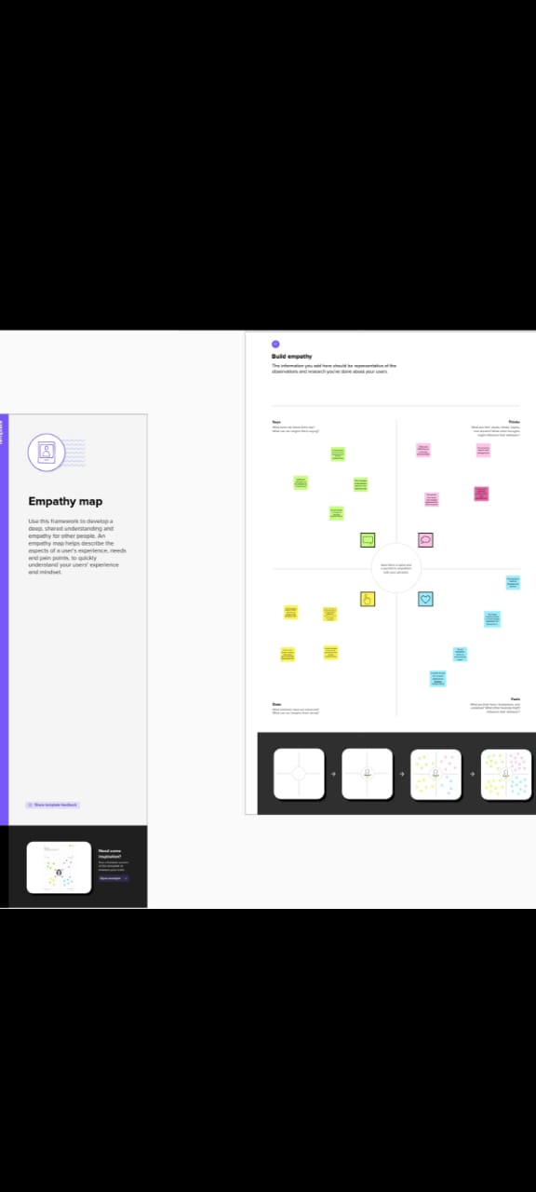EMPATHY MAP :